ManoMitra: A Safety-First Multi-Role AI-Driven Mental Health Support Platform
Varun Bantia, Prathyusha K, Venkatashiva C Reddy, Mr. Jerrin Joe Francis
Department of Computer Science and Engineering Presidency University

Abstract—The current developments in the sphere of conversa-tional artificial intelligence offer us new ways of offering mental health support that can be effectively scaled in a range of various channels. Digital AI-based applications are increasingly becoming popular as another form of emotional support in situations where a professional aid may not be delivered in time. Nonetheless, the application of AI technology to the mental health field needs to be thoroughly planned in relation to safety, consistency, and reliability. Unfiltered and inappropriate replies from AI ChatBot might occur in critical circumstances, like a state of self-harm ideation, putting one in harm’s way.
In this paper, a multi-component system named ManoMitra is suggested to provide multi-layered mental health care assistance, grounded on the combination of AI and human supervision. The system incorporates an AI-based conversational assistant into a process of professional counseling, as well as implements crisis detection and monitoring mechanisms, together with institutional anonymized analytics. The two-tiered safety model comprising the semantic safety module and the large language model is the main part of the system. In particular, user inputs are first run through a semantic safety model which culls out any inappropriate content before passing the information to the large language model. As a result, the two-tiered strategy avoids the creation of toxic responses without affecting the flow of conversation and sympathy.

- Introduction
There has been an improvement in conversational agents over the years. What used to be just a simple rule-basing system developed into complex transformer-based systems with the ability to comprehend the context and produce human-like responses. Even primitive systems like ELIZA demonstrated that even the simplest conversational rules could produce a feeling of emotional attachment and therapeutic. interaction [1]. As the large-scale models, such as GPT-3, have been introduced, the conversational systems are much more potent now and can work with complex language and generate coherent responses in a vast variety of situations. [2] [3]
Simultaneously, specially developed conversational plat-forms that support mental health have been highlighted as scal-able and available solutions. Chatbots are applicable to struc-tured intervention, e.g., cognitive behavioral therapy (CBT) and to generate material outcomes in terms of mental health of the user, such as applications such as Woebot (2017) [4]. Similarly, sympathetic digital agents have shown that sym-pathetic and empathetic conversations can help to positively affect the emotional state of the users. [5].
But amid such developments, many of the existing systems still rely on pre-defined scripts or centralized cloud-based moderation. This can make them inflexible, slow responding, and in other instances, they cannot adjust to needs of individual users. It also raises concerns, which relate to data privacy especially when sensitive mental health information is sent out of the premises. More to the point, the answer offered by the generative AI systems with no significant protection can be either unsuitable or hazardous, particularly, in the case of emergency cases or suicidal ideation. Studies in AI safety emphasize the need to use several layers of protection in the deployment of smart systems in areas that are so important. [6], [7].
These difficulties are suggestive of the fact that there ought to be a more balanced approach to the problem i.e. a mix of intelligent dialogue and solid safety measures.
In response to this, we present, ManoMitra an all-encompassing mental health support platform leveraging ar-tificial intelligence and structured human support in Android.. As opposed to being a mere chatbot, ManoMitra integrates various features, such as AI-based dialogue, professional counseling, peer-support groups that are moderated, crisis detection, and institution-specific anonymized analytics. The platform is created with a role-based system that consists of Students, Counselors and Administrators. Students can reach an AI helper which is safety-aware, track their mood, make a counseling appointment, and use safe communication as soon as a counseling appointment is made. Counselors have to deal with the appointment management and address critical cases whereas the administrators obtain the insights into the overall trends in mental health, not receiving any personally identifiable information.
The hybrid and safety-first design is one of the strong points of ManoMitra. Any type of response is first formed by processing user inputs with a lightweight on-device risk detection model. In case a message is perceived to be harmful, the system will not proceed with normal AI responses. Rather, it triggers structured support processes, including supplying crisis resources or advice. In addition, the site possesses certain key characteristics that can be a single account/single role security system, multiple languages in accordance with regional languages to make the site more accessible, and anonymous log-ins to minimize the stigma and encourage the early seeking of help among the site users.
Intelligent AI and combining it with professional care and

a robust sense of safety and privacy, ManoMitra shows how digital mental health systems can be created to be both responsible and scalable
- Literature Review
The emerging mental health systems based on AI combine concepts across various research fields, such as conversational agents, large language models, suicide risk prediction, digital therapy platforms, and AI safety. With time, scientists have strived to make these systems more attentive to the context of the user, to respond to the user with understanding, and to be safe- particularly in cases where the user might be in danger. Here we consider some of the key recent research in these directions and point out the gaps that prompted the creation of ManoMitra.
- Conversational Agents in Therapeutic Contexts
In recent years, conversational agents have demonstrated a great potential to assist mental health. Researchers such as Wang et al [8] indicate that chatbots may be used to detect the signs of psychological distress at an early stage by assessing the way visitors speak to the chatbot [8]. On the same note, Shing et al [9] demonstrated that conversational AI is capable of pattern recognition of emotions and offers scalable assistance to a vast number of users. Although these systems enhance access and availability of mental health services, they usually falter in the face of acute or risky scenarios, since most of them are weak in terms of safety.
- Transformer-Based Language Models
The large language models (LLMs) have contributed signif-icantly to the enhancement of conversational systems. Bom-masani et al. [7]. talked about how these models can be used to produce detailed and context-sensitive responses, which make interactions seem more natural. Nevertheless, these models have their flaws. They may occasionally give wrong or inaccurate answers, particularly in sensitive fields such as mental health. The literature by Liu et al. indicates that the incorporation of emotion-sensitive elements can enhance comprehension, yet it is not the complete solution to the issue of providing safe answers when having a conversation in real-time, as it is demonstrated by them in the article by Liu et al. [12].
- Digital Mental Health Interventions
Mental health support is being offered on AI-powered platforms, at scale. Wang et al. [8] have proven that deep learning models may examine user texts to evaluate mental health conditions as well. Pham et al. [10] investigated more sophisticated methods of integrating other kinds of data, like text and context, to identify suicide risk more effectively. Although these methods have potential, most of them require cloud services and fail to provide real-time safety enforcing measures, which may restrict their use in real-time interac-tions.
- Suicide Ideation Detection Using Deep Learning
The issue of suicide risk prediction with deep learning has become a significant research topic. Ji et al. [11] outlined the various methods of machine learning in detail, noting that neural networks are better able to derive deeper meaning out of what the user typed in. Specifically, attention-based models assist in paying attention to emotionally significant words and enhancing the detection rates of words and phrases [12]. Nevertheless, majority of these models are experimented in offline settings with pre-gathered data. This complicates their direct application to real time systems where there is a need to have fast and accurate response.
- AI Safety and Secure Deployment
The safety has become a significant issue as AI systems are increasingly applied to sensitive areas. According to Bom-masani et al. [7], organised safety provisions in advanced AI systems are necessary. Moreover, user privacy is particularly essential when it comes to mental health applications as personal information is extremely sensitive in this case [22]. Although it has been noted that privacy preserving mecha-nisms and safe deployment measures have been made, the incorporation of real-time safety measures into conversational systems remains an issue that has not been addressed com-pletely.
- Research Gap
Despite the major advances made in this area, there are still a number of significant drawbacks:
  - Not all conversational agents are well-endowed with real-time safety filtering.
  - suicide detection models are typically offline but not in real-time systems.
  - Generative AI systems do not have safety check prior to generating responses.
  - Cloud-based processing is a common solution to many of them and this is an issue of privacy.
To solve these problems, ManoMitra proposes a more balanced and safety oriented strategy:
    - A BiLSTM-attention suicide risk detection model on-device. item A neural classifier with a lightweight, mobile efficient implementation.
    - A strict safety check before generating any AI response.
    - Structured support for crisis situations.
    - A multi-role system that combines AI assistance with professional human support.
ManoMitra, by unifying the latest developments in the fields of deep learning, AI safety, and mobile system design, will develop a mental health platform that is not only scalable but also safe, reliable, and responsible
- Hybrid Safety Model Architecture
- Design Motivation
Safety is of paramount importance when conversational AI is applied in mental health. The system must be able to

recognize what the user is saying and ensure that its answers do not hurt anyone, particularly when the user could be in a distress or when the user could be having thoughts about harming himself or herself. Uncontrolled purely generative AI models are occasionally unsafe and inappropriate in their responses. Due to this fact, there should be a safety layer that should be able to analyze user input and then a response can be created.
In order to manage this, ManoMitra is a safety-first com-pany. All user messages will be analyzed by risk detection model directly on the users device even before it can get to the major conversational system. This assists in realizing risky or sensitive input earlier and enables the system to act in a more disciplined and accommodative manner. This system is quicker than more traditional systems that rely on a server-based moderation system, provides user privacy, and allows real-time decision-making.

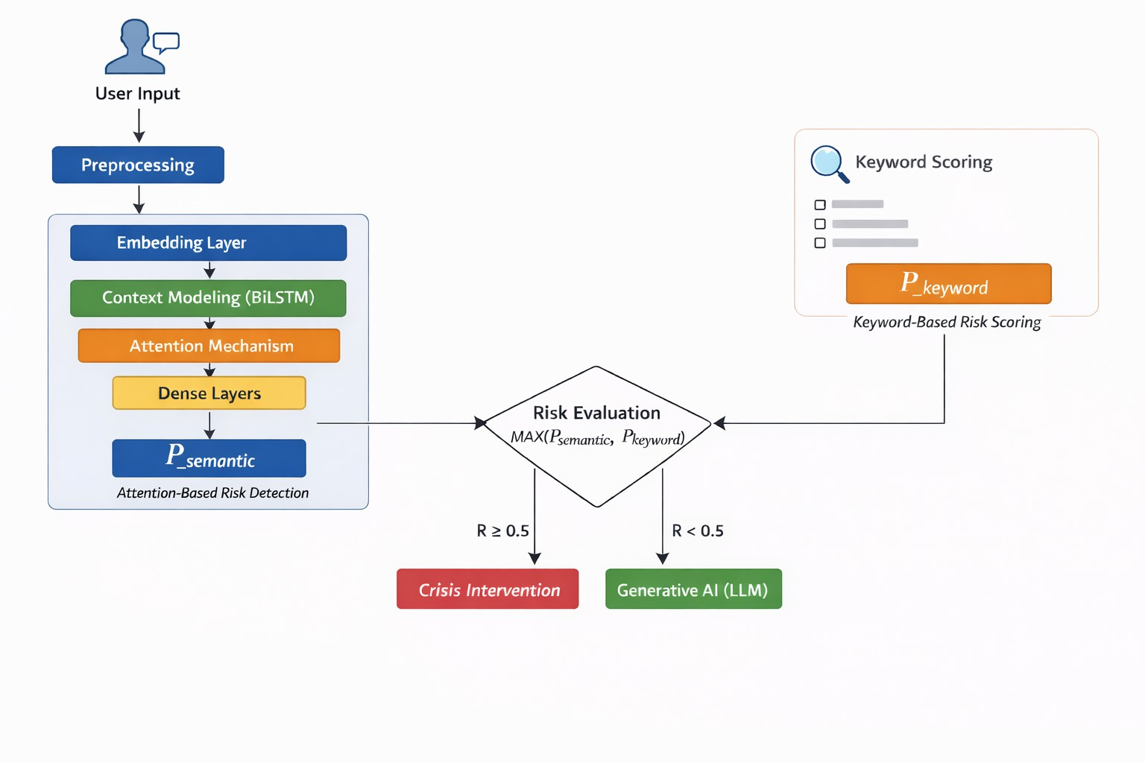
- Model Architecture

Fig. 1. Hybrid safety model architecture of ManoMitra

The system combines a BiLSTM-attention based semantic model with a keyword-based scoring mechanism to ensure safe responses in real time.
ManoMitra’s safety algorithm consists of a combination of both approaches mentioned before, such as recognizing the semantics of the user message and keyword detection. According to Fig. 1, the safety algorithm is executed in two components as follows:
  - Risk Detection through Semantics Recognition: In order to recognize risks through semantical analysis, the model is implemented based on a deep learning architecture capable of inferring risk from context and overall semantics of messages sent by the user [11], [12].
  - Keyword Detection for Reinforcement: While the model recognizes risks through semantic analysis, it uses the keyword approach to reinforce itself by finding specific keywords indicating possible risks.
- Text Representation: Initially, the input text is pre-processed by converting it into lowercase letters, deleting unwanted symbols, and dividing it into tokens. Next, tokens are transformed into numeric vectors with the help of an embedding layer (i.e., word embeddings). In other words, the system learns the sense of the word [13].
Let:

X = {x₁, x₂, ..., x_{n}}
be the sequence of words from the input.
- Contextual Sequence Modeling: To determine the con-text of the message, the bidirectional Long Short-Term Mem-ory (BiLSTM) model is used. The model is based on reading the sentence in two directions, from left to right and vice versa, that is, from right to left. Long Short-Term Memory (LSTM) models are capable of processing sequences and taking long-term dependencies into account [14], [15].

H = BiLSTM(X)
In this case, H denotes the contextual information about the input.
- Attention Mechanism: The attention layer is utilized for analyzing the importance of words from the sentence. All words have different weights concerning their significance, so this mechanism helps the model highlight the most emotional words from the sentence [17], [18].

A = Attention(H)
- Classification Layer: The obtained data will be further analyzed by fully-connected neural layers (FC layers) to get a final risk score. These layers allow the obtained information to be converted to probability that determines the potential harm.
  - Dense(64) + Rectified Linear Unit (ReLU) + Dropout(0.5)
  - Dense(32) + Rectified Linear Unit (ReLU) + Dropout(0.3)
  - Output(1) + Sigmoid
The following equation will be used to calculate the predic-tion for each observation.

yˆ = σ(Wx + b)
where x denotes the feature representation of the input text obtained from the attention layer, W and b are the learnable parameters of the model, and yˆ represents the predicted probability of the input being high-risk.
Binary cross-entropy (BCE) loss will be used to train the model.

L = −(y log(yˆ) + (1 − y) log(1 − yˆ))
where y ∈ {0, 1} is the ground truth label, with 0 indicating a safe message and 1 indicating a high-risk message.
Dropout mechanism will help to prevent overfitting [20].

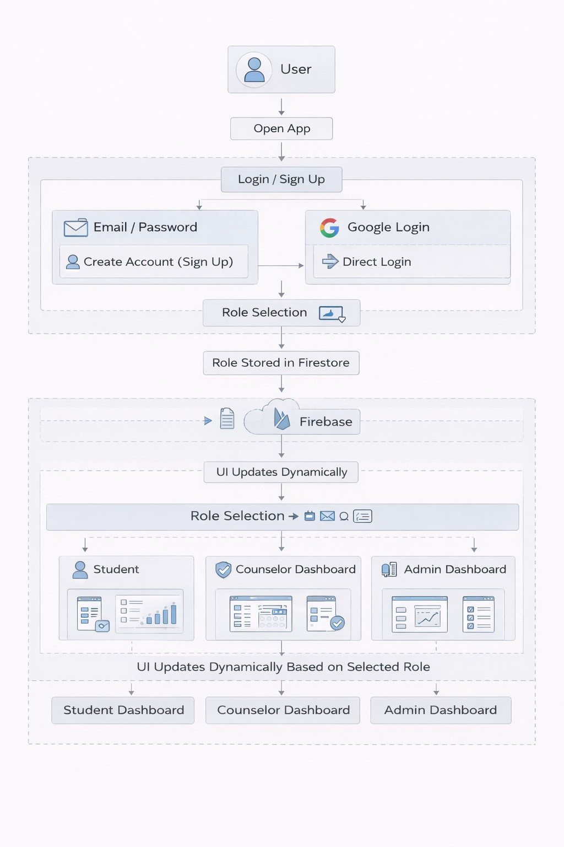
Fig. 2. ManoMitra Application Architecture

- System Architecture Overview
Android application ManoMitra is based on a modular ar-chitecture which enables the easy co-operation of different modules/components.
- TensorFlow Lite-based on-device AI safety filtering.
- LLM on Cloud to generate the right responses.
- Firebase Authentication to secure the services of login.
- Firebase Firestore to take care of the data storage.
- User-type-based role-based navigation.
The software architecture may be divided into three main layers:
  - Client Layer: Mobile client application to provide all user interface and role-based navigation.
  - Intelligence Layer: Local safety checking model along with AI chatbot integration.
  - Cloud Backend Layer: Authentication, analytics, and Firestore management.
Being careful to ensure that every user input is locally processed by the safety model before it is sent to the chatbot is one of the crucial considerations in the design of this architecture. This will not only contribute to the minimization of the response time but also guarantee privacy, which is one of the best practices in AI safety. [6], [7].
The architecture consists of client, intelligence, and cloud backend layers, ensuring that every user input is processed through the safety model before reaching the chatbot.
- Training Parameters
The model is implemented with the use of TensorFlow and Keras libraries and trained on a publicly available mental health-related dataset [16]. The data will be divided into 80 percent training set and 20 percent testing set.
Key parameters that should be considered include:
- Adam optimization method
- Learning rate of 0.001
- Early stopping due to validation results
- Dropout for generalization
The primary goal of the model training process is to avoid high-risk cases to be ignored despite some accuracy reduction.

- Mobile Deployment and Optimization
In order to deploy the system in mobiles and optimize its performance, the trained model is exported in TensorFlow Lite form. This leads to reduced storage requirement and improved performance while not compromising much on accuracy. Therefore, the system is able to function in real-time on the user’s device.

- Real-Time Safety Pipeline
The safety pipeline works step by step as follows:
  - The user enters a message, which is cleaned and tok-enized.
  - The semantic model calculates a risk score P_{semantic}.
  - The keyword-based system calculates another score P_{keyword}, representing the risk based on the presence of predefined critical keywords or phrases in the user input. These keywords indicate distress, self-harm, or suicidal intent and increase the risk score.
  - The final risk score is computed as:

R = max(Psemantic, Pkeyword)

This ensures that even if one method misses a risk signal, the other can still detect it.
  - If R ≥ 0.5, the system does not generate a normal chatbot response.
  - Instead, it activates a crisis support mechanism.
  - If the risk is low, the message is passed to the conver-sational AI.

- Comparison with Previous Research
Almost all previous works related to suicide prediction systems have been done to serve the purpose of offline analysis and have not been incorporated into live chat systems [11]. Likewise, conversational artificial intelligence models lack the feature to conduct a safety check before providing the answer. However, our system enhances existing research by provid-
ing:
- Real-time analysis of suicidal behavior
- Application of both deep learning and rule-based ap-proach for safety
- Strict screening for safety before generating answers
- Enhanced performance suitable for mobile devices
Incorporating both contextual awareness and attention, along with a rule-based system, makes this application a feasible approach in this field.

- System Implementation and Methodology
This section reports on how the framework of ManoMitra has been designed and implemented. The overall design is the mobile application and AI-supported safety model, user management with the notion of security and privacy, and effective data management. It aims to build a robust and scalable system which is both safe to operate in the context of mental health care.
- Algorithm: Safe Message Processing
Safe messages are dealt with by the system in the following manner:
  - The user enters a message M .
  - The message is captured by ChatController.
  - It is forwarded to the SafetyManager.
  - The ML model analyses the message.
  - The text is manipulated and translated into numerical input.
  - The model computes a risk score.
  - The message is forwarded to the chatbot.
  - If the score is less than or equal to 0.5, the message is marked as low risk.
  - The chatbot produces a response.
- Algorithm: Risk Detection and Safety Intervention
In case this message is risky, the system takes another route:
  - The user enters a message M .
  - The message is seen by the ChatController.
  - The ChatController captures the message.
  - It is passed to the SafetyManager.
  - The ML model evaluates the message.
  - The text is processed and converted into numerical input.
  - The model computes a risk score.
  - If the score is greater than or equal to 0.5, the message is marked as high risk.
  - The chatbot response is blocked.
  - Instead, a safety response (such as helpline information) is shown.
- Role-Based Access Control
The system has a rigid role-based model whereby every user has a single role.
  - The user logs into the application through email or Google account or anonymously.
  - The system requests the role of the user at Firestore.
  - The role is stored locally.
  - The app opens the right interface as per the role.
The security regulations ensure that nobody is able to alter roles thus preventing misappropriation [21].
- Overview of the Professional Counseling Booking Work-flow
This section will briefly describe the Professional Counsel-ing Booking Workflow.
Reservation of professional counseling sessions in ManoMi-tra has a structured, state-coordinated process that is aimed at
providing clinical responsibility and facilitating the interaction of users and counselors:
Selection → Pending → Confirmed → In-Progress →
Completed → Feedback
First, a user would talk to the system to choose a counselor and a slot of time available, which would initiate an atomic Firestore transaction to avoid scheduling errors. After sub-mission the session is placed in a state of Pending counselor review, and is changed to a state of Confirmed after validation. Scheduling of automatic reminders is then done to maintain time. The session transitions to an In-Progress state during the specified period, allowing the real-time communication through the Agora voice or video layers. Once the session is over, it will be indicated as Completed and stored in the history of the session, and will eventually remind the user to provide a feedback to update their longitudinal wellness index. An end-to-end lifecycle will make sure that all professional communications will be organized, clear, and data-driven in the ManoMitra ecosystem.
- Safe Student-Counselor Chatting
Only after confirming the booking can users exchange messages with the counselor. This way, users’ communication becomes secure and authenticated.
All conversations are stored in a safe database with appro-priate access.
- Aggregating Anonymous Analytical Data
The system gathers general information for analysis pur-poses. This allows educational organizations to have insights without obtaining private information from users.
Such practices encourage privacy-preserving data manage-ment [22].
- Moderation of Peer Community
This part of the app has automatic filtering and reporting mechanisms to foster a safe interaction space among users.
- Multilingual Support
The app is multilingual, which ensures that it can be used by more people.
- Wellness and Self-Care
The Wellness Hub offers tools for focus, breathing, and other activities. The good thing about these tools is that they are available even without the Internet and AI.
- Evaluation and Results
- Experimental Results

TABLE I
System Performance Metrics across Data Slices

Analysis Scenario | Accuracy | Precision | Recall | F1-Score
Global Dataset Performance  Specialized Clinical Evaluation | 94.29%  85.30% | 0.9560  0.8420 | 0.9420  0.8680 | 0.9490  0.8548

TABLE II
Performance Matrix Breakdown (N = 1, 000)

Metric Category | Final Count | Result Interpretation
True Positive (TP) | 434 | Correct Crisis Identification
True Negative (TN) | 419 | Correct Safe Message Approval
False Positive (FP) | 81 | Minimized Erroneous Intervention
False Negative (FN) | 66 | Minimized Safety Gaps

To analyze the effectiveness of the ManoMitra safety model, the experiments were performed using datasets, which in-cluded not only general conversational information but also messages related to mental health crisis. They were evaluated using standard metrics of evaluation like accuracy, precision, recall, and F1-score as in Table I.
The model demonstrated a high accuracy of 94.29% in the general validation dataset, suggesting high overall performance in a variety of conversational situations. But, with the exclusive test set, the accuracy increased to 85.30%, which is an indi-cation of improved handling of the complexity and sensitivity of crisis detection tasks.
The results of classification breakdown are also provided in detail in Table II. The model made the correct prediction of 434 high-risk cases (True Positives) and 419 safe messages (True Negatives). Nevertheless, it had 81 false positives, in which the safe messages were detected as risky, and 66 false negatives in which the real cases of crisis were missed.
High-risk detection has a recall of 0.8680, which implies that the model can detect most of the critical cases, with fewer cases not detected. The precision of 0.8420 indicates a stronger confidence in predicted risk cases.
- Safety Interpretation
In mental health systems, not all types of errors have the same impact. False negatives (a high-risk case missed) can be harmful, since they may postpone or bar required action. False positives, on the contrary, merely add a cautionary measure, like eliciting protective actions or alerts.
The model has a balanced trade-off between accuracy and safety. Although this has some false positives, this is tolerable in safety-critical applications where it is critical that risk de-tection is prioritized. Such a strategy aligns with the previous studies in suicide risk detection [11].
In general, the findings reveal that the ManoMitra system puts safety at the highest priority as the majority of the high-risk cases are identified, but at the cost of a slight decrease in the overall accuracy. This renders the system applicable in real world applications in mental health support systems.
- System Interface Evaluation
The user-interface of the ManoMitra application is illus-trated by the following figures.
Home Screen Interface Explanation: The users interact with the home screen first, and it is expected to be friendly and comforting, welcoming users with a friendly message and making it clear that the app is a safe place. With simple moods such as Good, Okay, Low, Very Low, users can easily

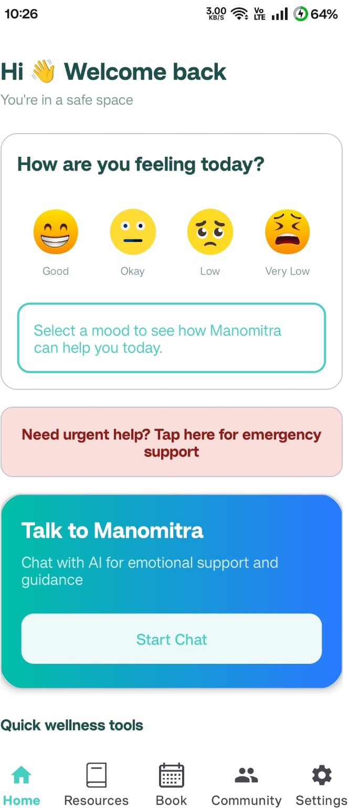

Fig. 3. Home Screen Interface of ManoMitra

express how they feel using simple emojis, enabling fast communication, quick access to support, emergency help, AI chat, and easy navigation through resources, booking, and community sections.
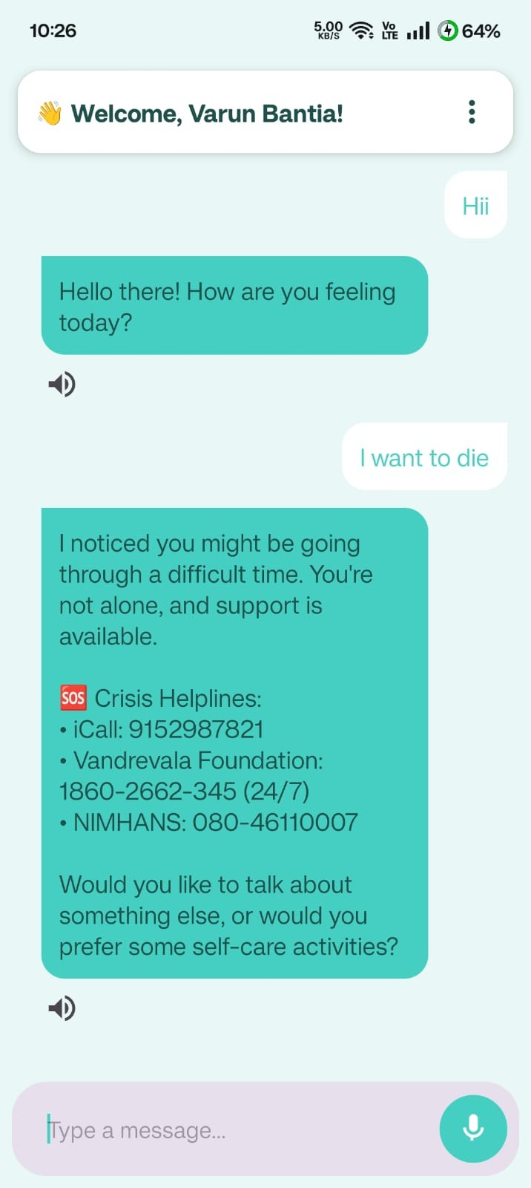
Fig. 4. AI Chatbot Interaction with Safety Response

Chatbot Safety Interaction Explanation: This interface shows the chatbot interacting in a friendly, non-aggressive

manner with an inviting prompt, recognizing user emotions and offering helpful assistance such as confirmed helpline data in a reassuring tone. The clean chat design, text-to-speech, and prompts improve accessibility while emphasizing safety and responsible interaction.
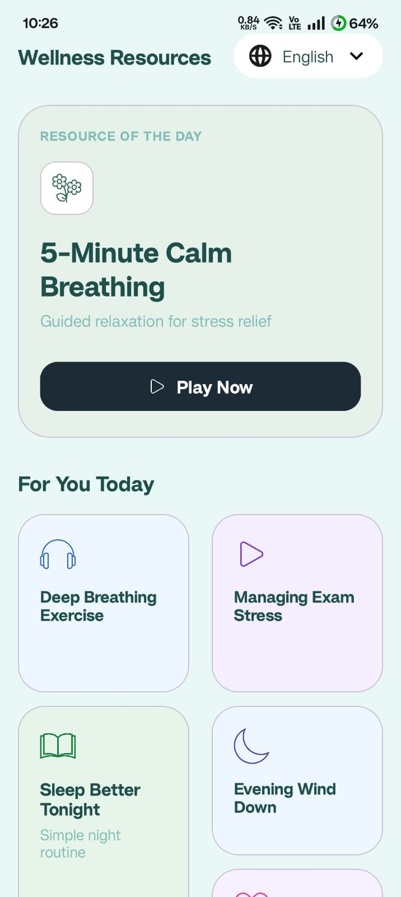
Fig. 5. Wellness Resources Interface
Wellness Resources Interface Explanation: This screen helps people take care of their health by showing a Resource of the Day like a breathing exercise with a Play Now button to start easily, along with options like relaxation, stress manage-ment, and sleep improvement. The simple design with calm visuals makes it easy to use, helping users build healthy habits and manage stress in a simple way.
Support Booking Interface Explanation: The display allows users to connect with professional assistance in a secure and confidential manner and book a counselor or call a helpline volunteer, with the choice of options being clear and simple to choose. It also enables users to book, has an emergency help button and easy access to support without confusion and hesitation.
Peer Support Interface Explanation: The screen enables the user to socialize with other people in a safe and anonymous setting, and users can browse the topics and engage with other users in terms of likes and comments. Share is easy with a simple design and New Post button, which assists in creating a feeling of community and alleviating loneliness.
- User–Chatbot Interaction Evaluation
In addition to the numerical analysis, we also experimented with the behavior of the system in natural dialogs. It was aimed at testing whether the chatbot will react properly in various scenarios, as well as whether the safety mechanism functions properly in real time.

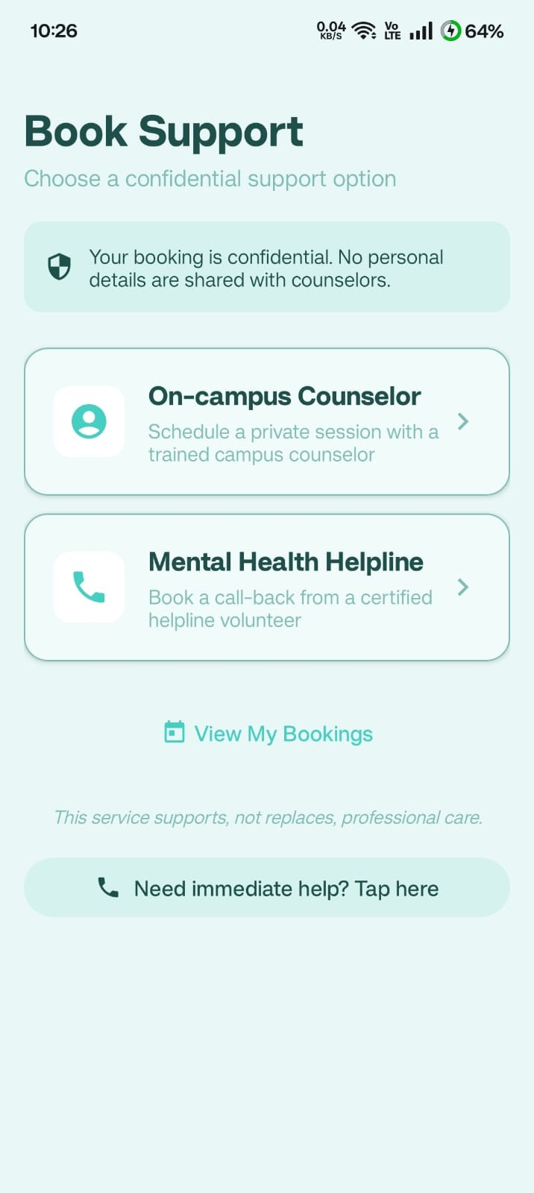

Fig. 6. Confidential Support Booking Interface
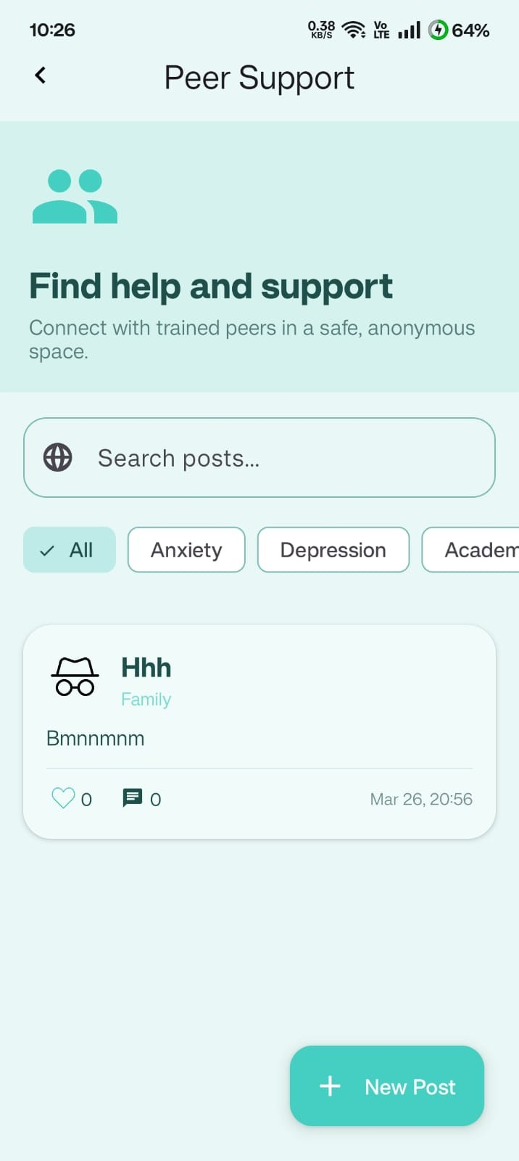

Fig. 7. Peer Support Interface

Case 1: Normal Emotional Support.
User Input: I am under stress due to my exams.
Safety Model Output (Risk Score): 0.18 Safety Decision: Safe
Chatbot Response: It is like exam preparation is putting a strain on you. Exam stress is a normal thing. Would you like a short breathing exercise or would you like to talk about how

to manage your time?
Analysis: The system was able to identify this as a normal case, and give beneficial and helpful advice.
Case 2: Medium Distress (Borderline Case)
User Input: I am hopeless about everything at times.
Safety Model Output (Risk Score): 0.46 Safety Decision: Safe
Analysis: The system was able to identify that the user was feeling low but not in acute danger. It enabled the dialogue to flow, and at the same time, it maintained a supportive tone.
Case 3: High-Risk Expression
User Input: I do not want to live any more. Safety Model Output (Risk Score): 0.92 Safety Decision: High Risk.
Analysis: This was a dire situation that was immediately recognized by the system. It prevented regular responses of chatbots and turned on the crisis support system.
Case 4: Expression of Indirect Risk.
User Input: I hope it all would come to an end.
Safety Model Output (Risk Score): 0.81 Safety Decision: High Risk.
Analysis: Although the message was indirect, the system could have considered the message behind it and categorized it as a high-risk message.
Case 5: Multilingual Interaction
User Input (Hindi): Main bahut mehsoos kar raha hoon.
Safety Model Output (Risk Score): 0.24 Safety Decision: Safe
Analysis: The system was flexible and dealt with the multilingual input in the right way and reacted accordingly.
- Observations and Behavioral Analysis
The test results indicate that the system works according to the expectations in various conditions. There was a con-sistent triggering of high-risk messages through consistent safety responses and normal messages through regular chatbot interaction. The system is intentionaly designed to be cautious. It might occasionally categorize safe messages as risky but it is okay since it does not miss out serious cases. When working with mental health, it is never too late to be cautious and neglect a serious case of a situation [6]. All in all, the findings indicate that the safety-first design of the hybrid nature of the ManoMitra is effective and can be trusted to perform in the real world. To further enhance the system we can add additional languages and test it at a larger scale.
- Conclusion
In the current paper, we presented ManoMitra, a mental health support platform that uses AI to offer accessible, reliable and safe help. The system also has a distinctive hybrid safety pipeline which is a combination of on device BiLSTM models, attention mechanisms and keyword-based checks to detect risky messages and direct users to the right support. With these stringent safety measures coupled with an intelligent cloud-based language model, ManoMitra can
be sure that the interactions are safe and trusted even under the most sensitive circumstances. This proactive measure will enable the platform to identify vital signs early on, closing the disconnect between automated AI reactions and the urgent action of human-centered crisis management.
In addition to its fundamental safety aspects, ManoMitra also provides an extensive support space such as role-based access, peer support, and wellness options that are privacy-and scalability-conscious. The assessment outcomes prove that the system is well balanced in terms of high-accuracy risk detection and a natural, conversational experience on its multi-layered structure.
The future will be dedicated to the further development of the language support, incorporation of more sophisticated transformer-based AI models, and the pilot experiments in the real-life setting of various communities. Finally, ManoMitra shows how the responsible design of AI based on thought-fulness and ethical considerations can turn it into an ethical, user-centric instrument of mental health advocacy on a global scale.
References
- J. Weizenbaum, “ELIZA—A computer program for the study of natural language communication between man and machine,” Communications of the ACM, vol. 9, no. 1, pp. 36–45, 1966.
- T. Brown et al., “Language models are few-shot learners,” in Advances in Neural Information Processing Systems (NeurIPS), 2020.
- E. M. Bender et al., “On the dangers of stochastic parrots: Can language models be too big?,” in Proceedings of the 2021 ACM Conference on Fairness, Accountability, and Transparency (FAccT), 2021.
- K. K. Fitzpatrick, A. Darcy, and M. Vierhile, “Delivering cognitive behavioral therapy to young adults with symptoms of depression and anxiety using a fully automated conversational agent,” JMIR Mental Health, vol. 4, no. 2, 2017.
- B. Inkster et al., “An empathy-driven conversational artificial intelligence agent for digital mental well-being,” JMIR mHealth and uHealth, vol. 6, no. 11, 2018.
- D. Amodei et al., “Concrete problems in AI safety,” arXiv:1606.06565, 2016.
- R. Bommasani et al., “On the opportunities and risks of foundation models,” 2022.
- Y. Wang et al., “Mental health detection in social media using deep learning,” IEEE Access, vol. 10, 2022.
- H. Shing et al., “Natural language processing for mental health detection: Recent advances,” ACL Findings, 2023.
- T. Pham et al., “Deep learning for suicide risk detection: A multimodal approach,” Information Processing & Management, vol. 60, no. 2, 2023.
- S. Ji, C. Pan, X. Li, Z. Cambria, and E. Long, “Suicidal ideation detection: A survey of machine learning approaches,” ACM Computing Surveys, vol. 55, no. 1, 2022.
- X. Liu et al., “Emotion-aware mental health detection using attention-based neural networks,” IEEE Transactions on Affective Computing, 2024.
- T. Mikolov et al., “Distributed representations of words and phrases and their compositionality,” in NeurIPS, 2013.
- S. Hochreiter and J. Schmidhuber, “Long short-term memory,” Neural Computation, vol. 9, no. 8, pp. 1735–1780, 1997.
- A. Graves, A.-r. Mohamed, and G. Hinton, “Speech recognition with deep recurrent neural networks,” in Proc. IEEE ICASSP, 2013.
- N. Komati, “Suicide and Depression Detec-tion Dataset,” Kaggle, 2021. [Online]. Available: https://www.kaggle.com/datasets/nikhileswarkomati/suicide-watch
- D. Bahdanau, K. Cho, and Y. Bengio, “Neural machine translation by jointly learning to align and translate,” in Proc. ICLR, 2015.
- Z. Yang et al., “Hierarchical attention networks for document classifi-cation,” in Proc. NAACL-HLT, 2016.

- I. Goodfellow, Y. Bengio, and A. Courville, Deep Learning. MIT Press, 2016.
- N. Srivastava et al., “Dropout: A simple way to prevent neural networks from overfitting,” Journal of Machine Learning Research, vol. 15, pp. 1929–1958, 2014.
- OWASP Foundation, “OWASP mobile security testing guide,” 2021. [Online]. Available: https://owasp.org
- Y. Pruksachatkun et al., “Privacy-preserving machine learning in health-care: A survey,” IEEE Access, vol. 9, 2021.

